**Purpose**:

The purpose of creating this document is to provide step by step instructions on how to create queues on UiPath Orchestrator.

Step 1: Login to UiPath cloud orechestrator: <http://cloud.uipath.com> and then go to the tenant.

Step2: Go to the folder by clicking folder name in the left pane and then click queue Icon from the top bar.

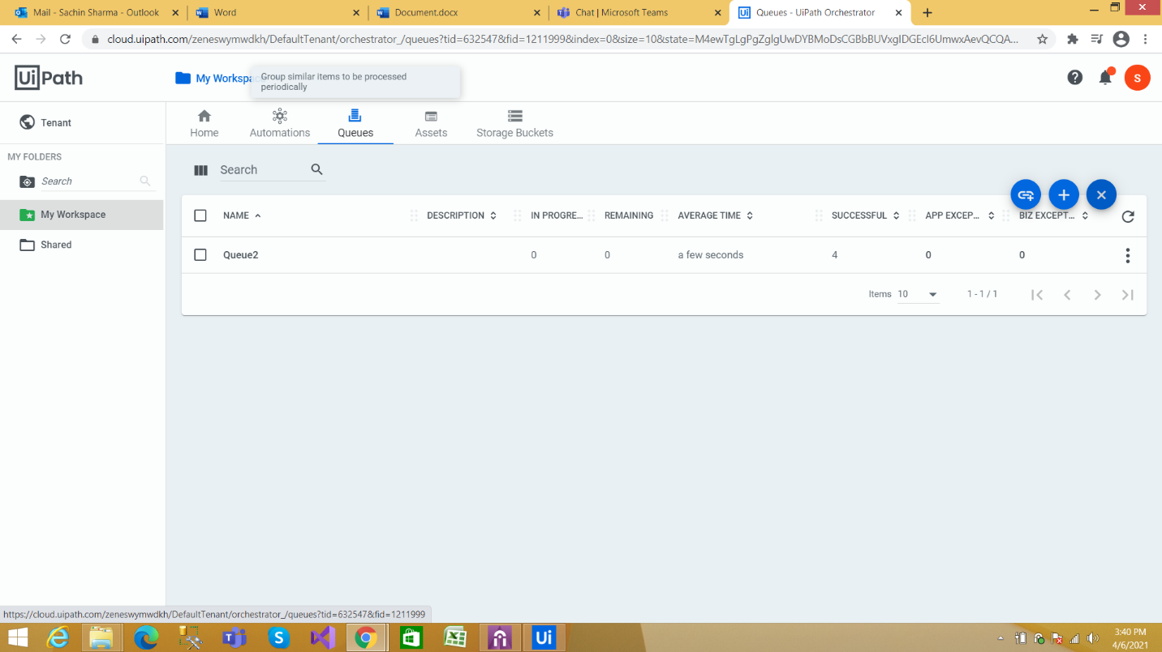

Step3: Now click on (+) Icon (blue icon that appears on the top right of queue list).This allows you to add a new queue as shown in the following screen grab.

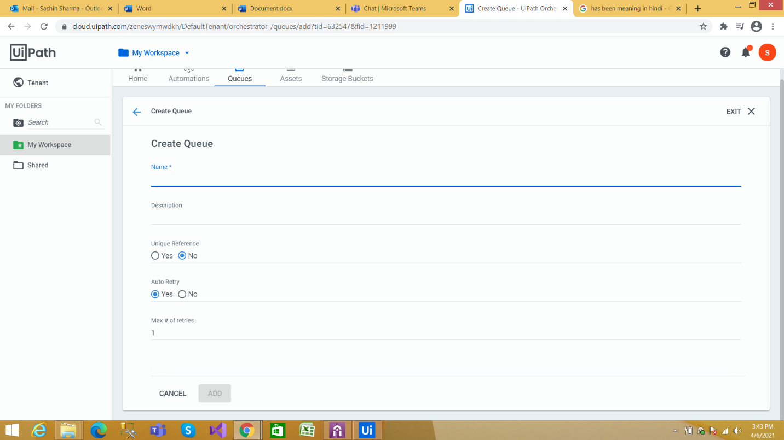

Step4: Enter queue information, description of each field is as explained below:

Queue Name – A unique name for the queue.

Description – A brief description of the queue.

Unique Reference - you can leave it blank for now and it can be used to filter the data),

Auto Retry - number of auto retry attempts before the transaction errors out.

Finally, Click Add button. This creates a new Queue.

Step5: Add Queue items in the queue.

There are two methods for adding queue item in orchestrator:

1. Add queue items using UiPath Studio Activity.
2. Upload functionality in Orchestrator

For illustration purpose, we are using first method to add items to the queue using Studio Activity and is explained in the following section.

Step 6: Now Create a new process in UiPath studio, as shown in the following figure:

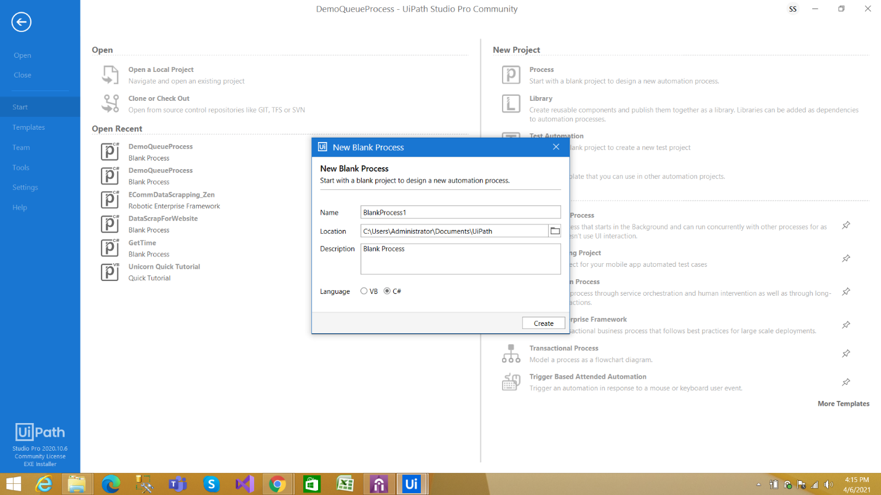

After creating new process, UiPath studio creates the project. Click ‘Open Main Workflow’ (Just below UiPath logo) to switch to the designer panel and proceed with next steps.

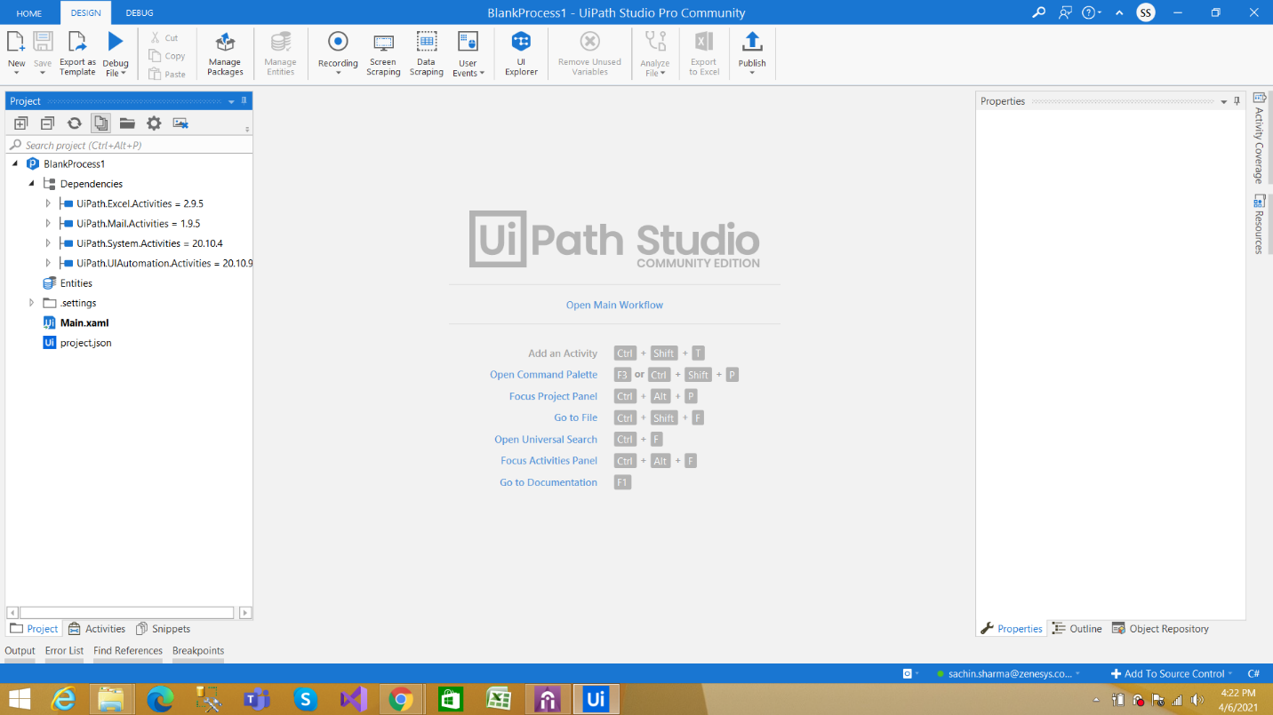

Step7: In this example, we are using excel file as source of queue items. This file in included in the code(Data folder) and is shown in the following figure.

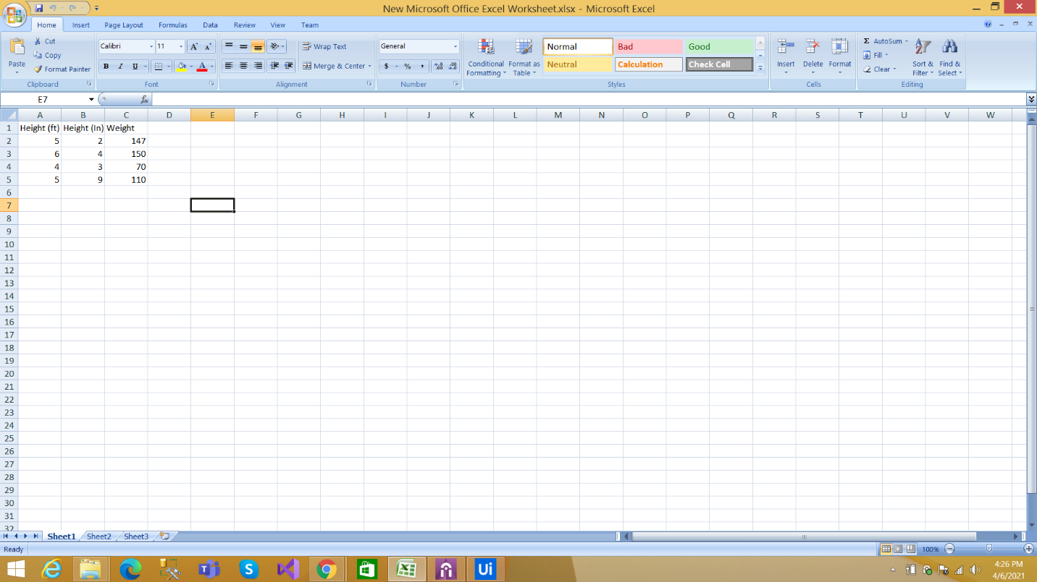

In this excel have three column Height(ft), Height (In) and Weight. These are height in feet, height in inches and weight.

Step8: Now go to the UiPath Studio and add a Flow chart in Process which we have already created above. This is shown in the following figure.

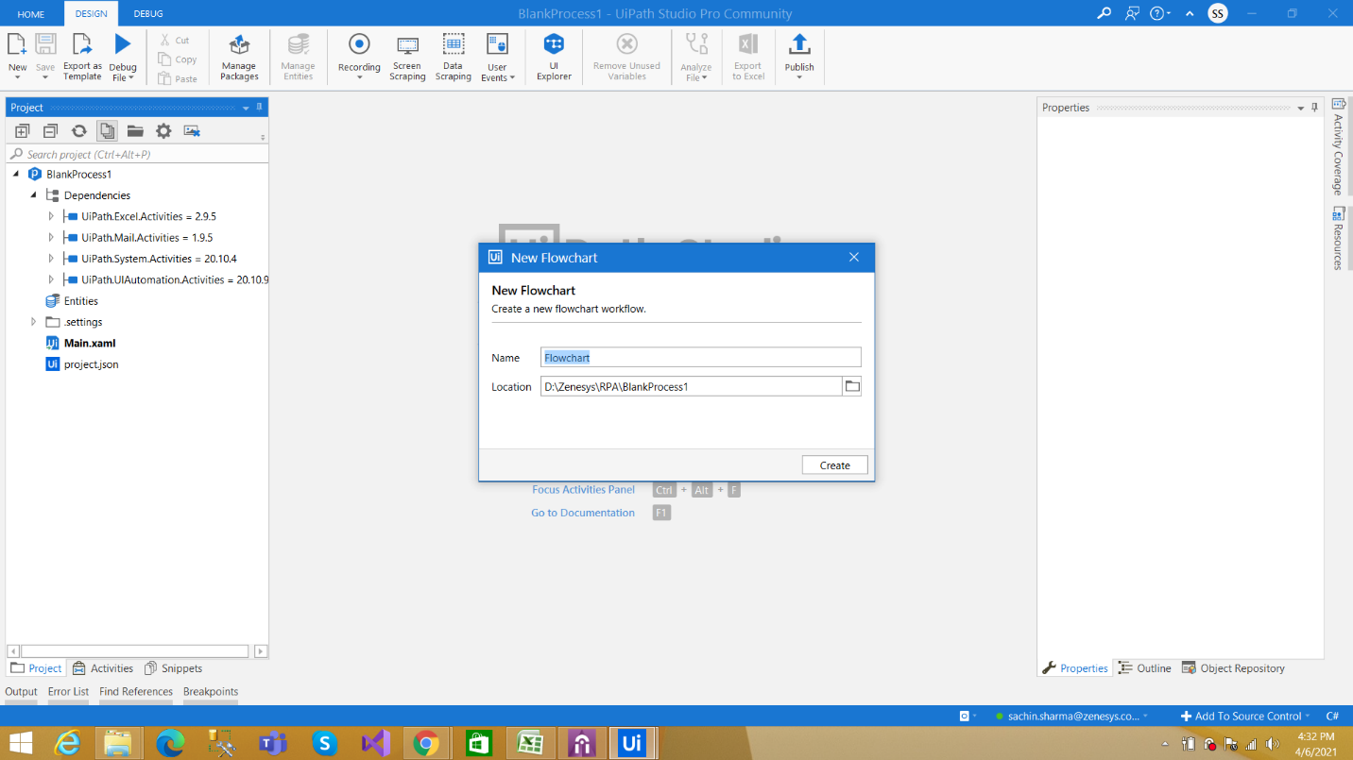

Provide a name and brief description (optionally), and click on Create button. This adds new flow chart.

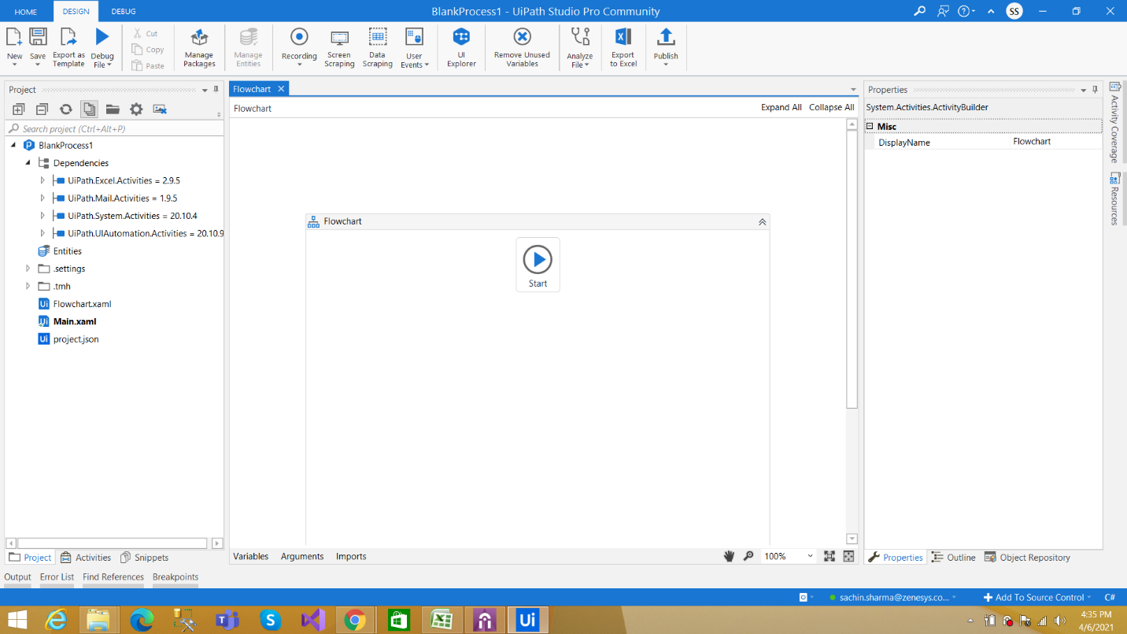

Step8: The next step is to add activities to add items in the queue. To read the excel data add the activity Read Range. Drag the Read Range activity from activities panel.

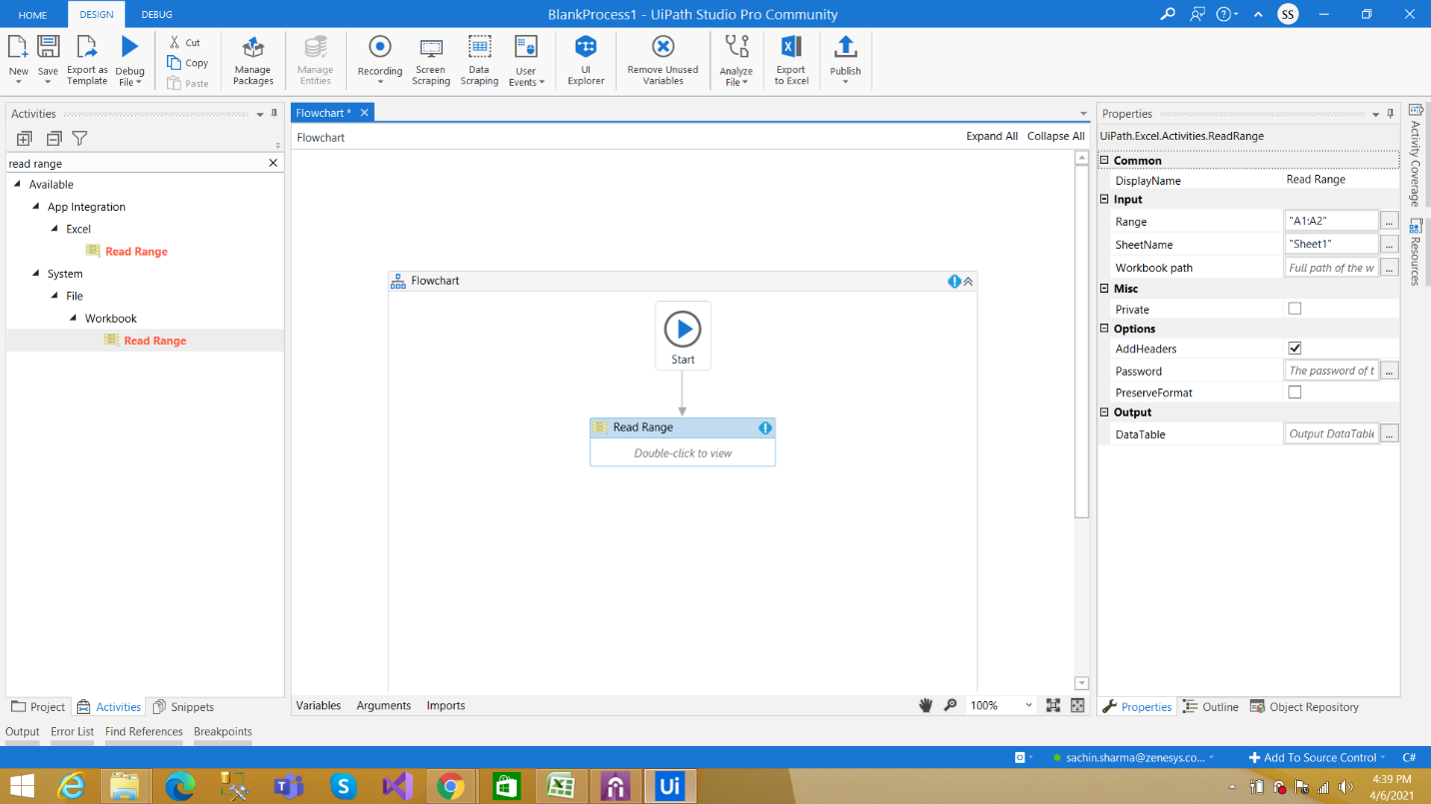

Now go to the properties and set the properties for Read Range Activity (as shown in the following figure).

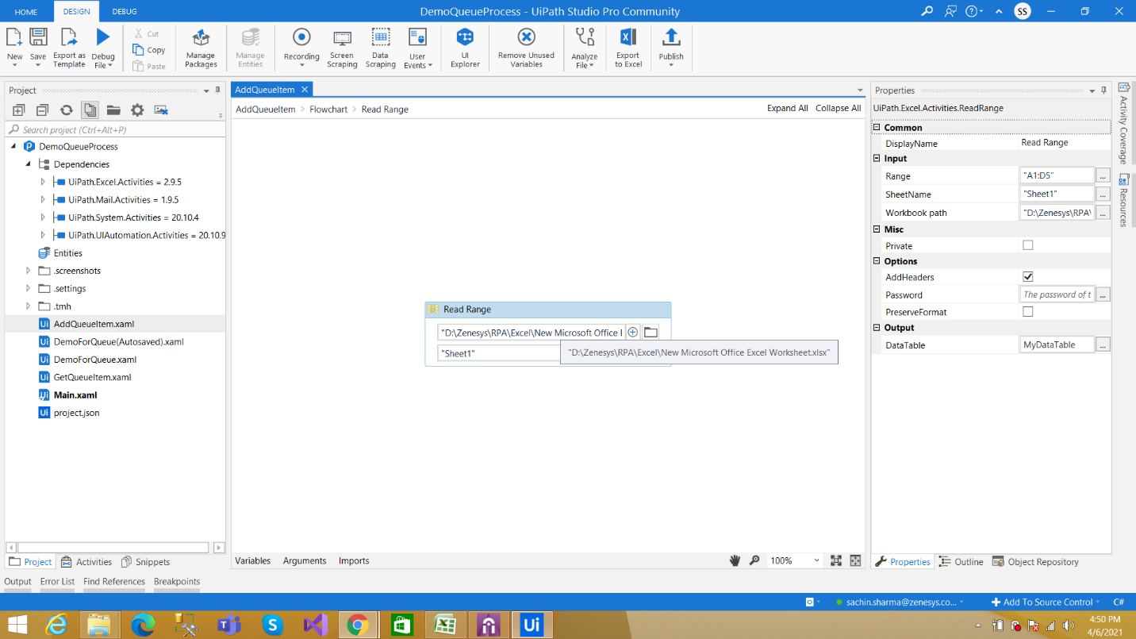

As a side note, make sure to check ‘Add Headers’ checkbox. This indicates that the first row in excel file are column headers. OutputTable Option shown in right side panel is table variable that gets filled with all the rows in excel sheet.

Step9: Now Add For each row activity and read each row from data table created in previous step.

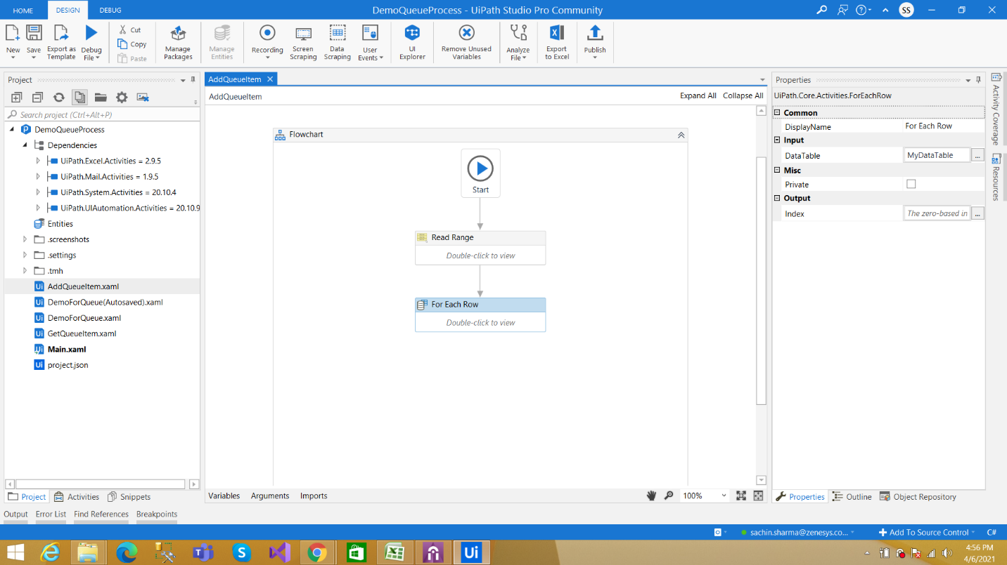

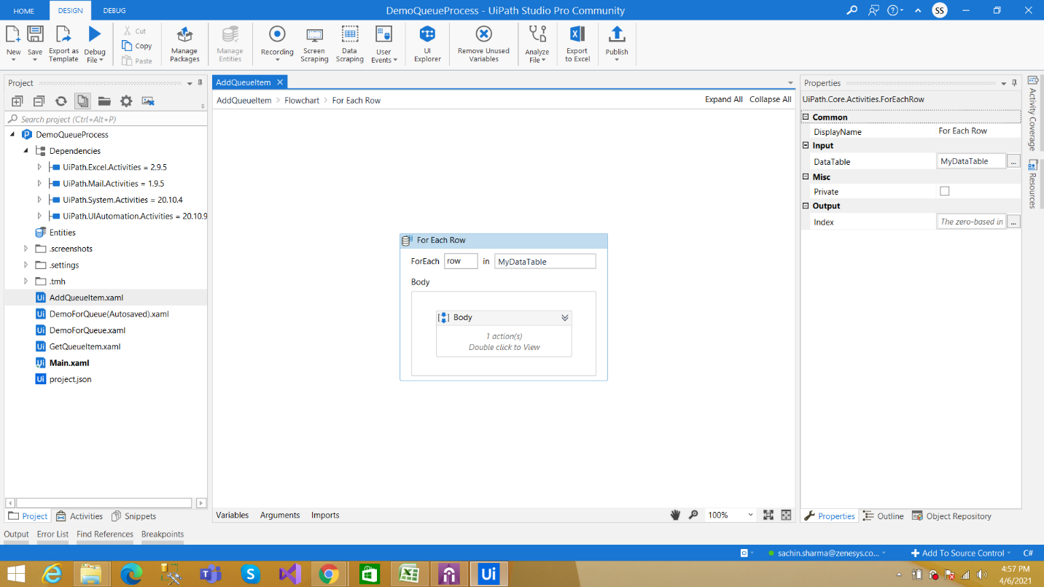

In the properties panel, use Datatbale Name as shown in above figure.

Step10: Add ‘Add Queue item’ activity in the for each loop, as shown in the following figure.

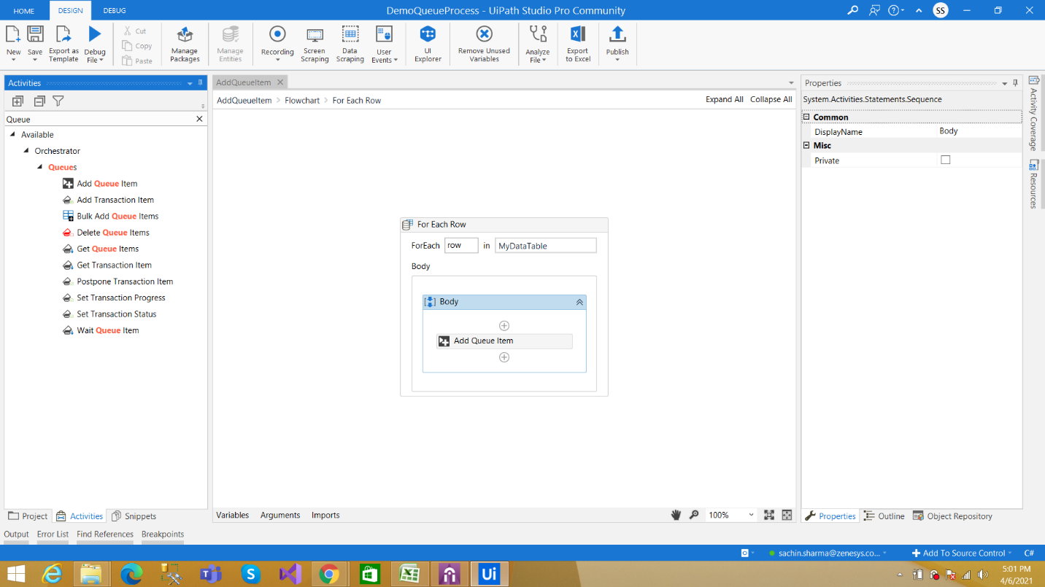

Step11: Set the properties of ‘Add Queue item’ activity as shown in the following figure.

QueueName should be same as the queue created in Orchestrator. As best practice, create a variable use that variable in the QueueName field.

Set other properties like Priority: High, Normal, Low and Item Information. Item information is a collection where you add arguments. This is shown in the following figure.

Fill the Name Arguments and Values (Datatable holds the excel data, write expression to provide the value) of Arguments as shown on following figure.

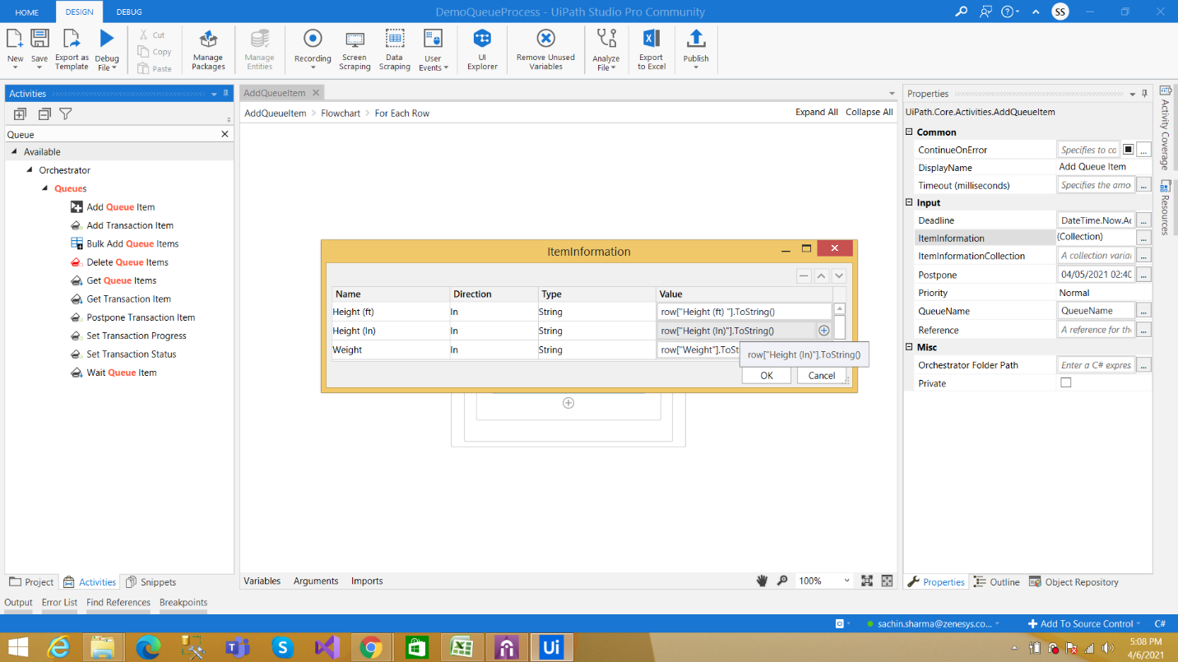

Step12: Now run the project in UiPah Studio. These rows in excel sheet will be added in the queue as queue item in the orchestrator.

To double check the queue item go to the Queue in orchestrator and click view transaction as shown in following figure

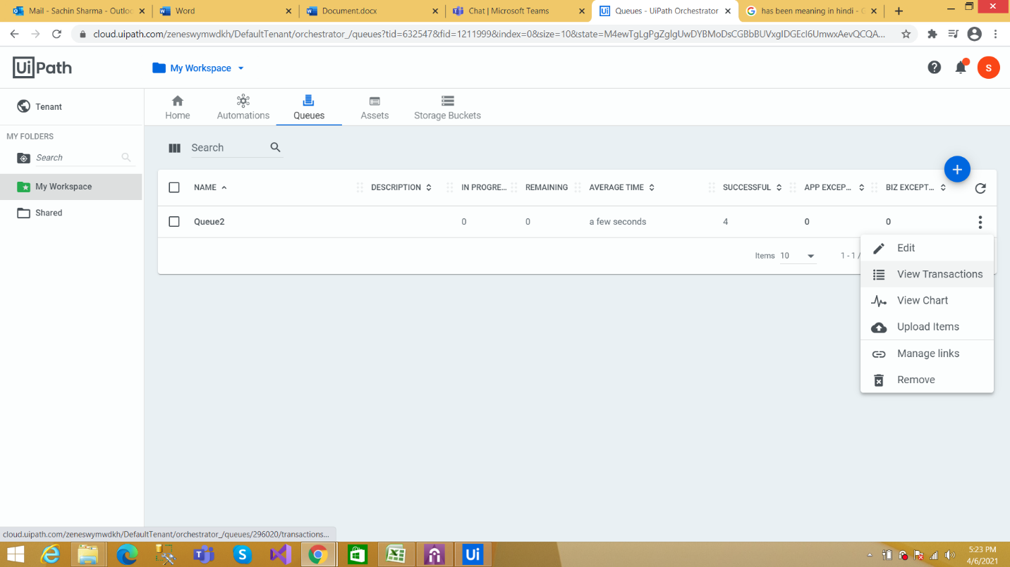

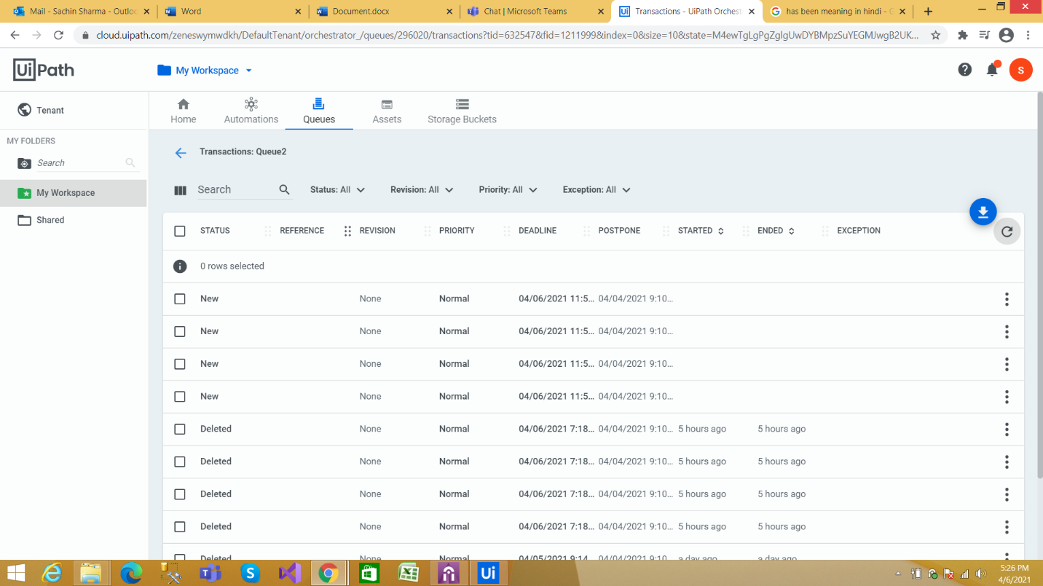

Now You can see that four Transaction added under the Queue.

**This concludes the explanation for adding Queues and Transactions.**